Marauder Dads

Promoting the future

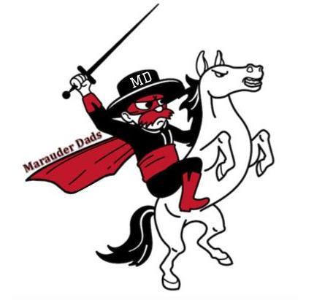

“Children whose fathers participate in classroom activities and school meetings and events receive higher grades, enjoy school more, and are more likely to participate in extracurricular activities”

We help to brighten our students’ days and school experience by bringing in fathers to greet everyone as they enter our school in order to create a more inclusive and engaging environment.

In order to do this, we need your help.

You can:

1. Volunteer to greet students as they enter
2. Pass this along to someone who might be able to help
3. Help Support Marauder Dads in other ways

Sign up using the provided link. Must also complete process for background check through Voly (link at end of signup).

<https://goo.gl/forms/PBJAg4iOEbdTq9tw2>



U.S. Department of Education, National Center for Education Statistics. Fathers' Involvement in Their Children's Schools, NCES 98-091,by Christine Winquist Nord, DeeAnn Brimhall, and Jerry West, Washington, DC: 1997.